**Project Design Phase-II**

**Data Flow Diagram & User Stories**

|  |  |
| --- | --- |
| Date | 20 October 2022 |
| Team ID | PNT2022TMID14000 |
| Project Name | Emerging Methods for Early Detection of Forest Fires |
| Maximum Marks | 4 Marks |

**Data Flow Diagrams:**

A Data Flow Diagram (DFD) is a traditional visual representation of the information flows within a system. A neat and clear DFD can depict the right amount of the system requirement graphically. It shows how data enters and leaves the system, what changes the information, and where data is stored.

**Example:**

FLOW □ It is difficult to predict and detect Forest Fire in a sparsely populated forest area.

□ it is more difficult if the prediction is done using ground-based methods like Camera

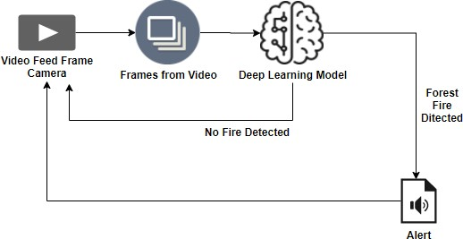or Video-Based approach.

□ Satellites can be an important source of data prior to and also during the Fire due to

its reliability and efficiency.

□ The various real-time forest fire detection and prediction approaches, with the goal of

informing the local fire authorities.

□ If the fire is not detected ,it will send the result to the frame camera.if the forest fire will detected the alert will go to the video feed frame camera.

**DFD:**

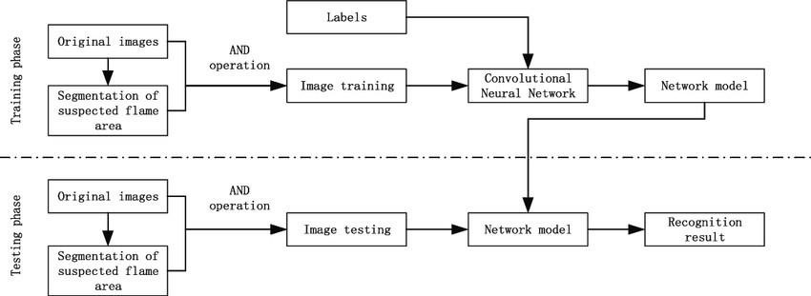

**User Stories**

Use the below template to list all the user stories for the product.

|  |  |  |  |  |  |  |
| --- | --- | --- | --- | --- | --- | --- |
| **User Type** | **Functional**  **Requirement (Epic)** | **User Story**  **Number** | **User Story** I **Task** | **Acceptance criteria** | **Priority** | **Release** |
| Environmenta  list | Collect the data | USN-1 | As an Environmentalist.it is necessary to collect the data of the | It is necessary to collect the right | High | Sprint-1 |
|  |  |  | forest which includes | data else the |  |  |
|  |  |  | temperature,humidity,wind and rain | prediction may |  |  |
|  |  |  | of the forest | become wrona |  |  |
|  |  | USN-2 | Identify algorithms that can be used for prediction | To collect the algorithm to identify the accuracy level of each algorithms | Medium | Sprint-2 |
|  | Implement | USN-3 | Identify the accuracy of each | Accuracy of each | High | Sprint-2 |
|  | Algorithm |  | algorithms | algorithm-calculated so that it is easy to obtain the  most accurate output |  |  |
|  |  | USN-4 | Evaluate the Dataset | Data is evaluated before processing | Medium | Sprint-1 |
|  | Evaluate | USN-5 | Identify accuracy,precision,recall of | These values are | High | Sprint-3 |
|  | Accuracy of  Algorithm |  | each algorithms | important for obtaining the riaht output |  |  |